|  |  |  |  |  |  |
| --- | --- | --- | --- | --- | --- |
| Date | 28-Nov-22 | | | Tester Name | Shahabuddin Syed |
| Environment | Penfax - Test | | | Login used |  |
| Operating System | Select OS | Version: | Update: | | |
| Software Used | Select Software | Version: | Update: | | |
| Select Software | Version: | Update: | | |
| Release version | 22.4.1 | | | | |
| Title | SRB | | | | |
| Test Type | Regression | | | | |
| Test Scenario | Process a spousal breakdown payment to a PRPP | | | | |
|  |  | | | | |
| Expected Results |  | | | | |
| Pass/Fail | Pass | | | JIRA# | N/A |

Describe your steps with screenshots:

Search form the stakeholder

Enter StakeholderID – “263050”

Click on their Stakeholder ID

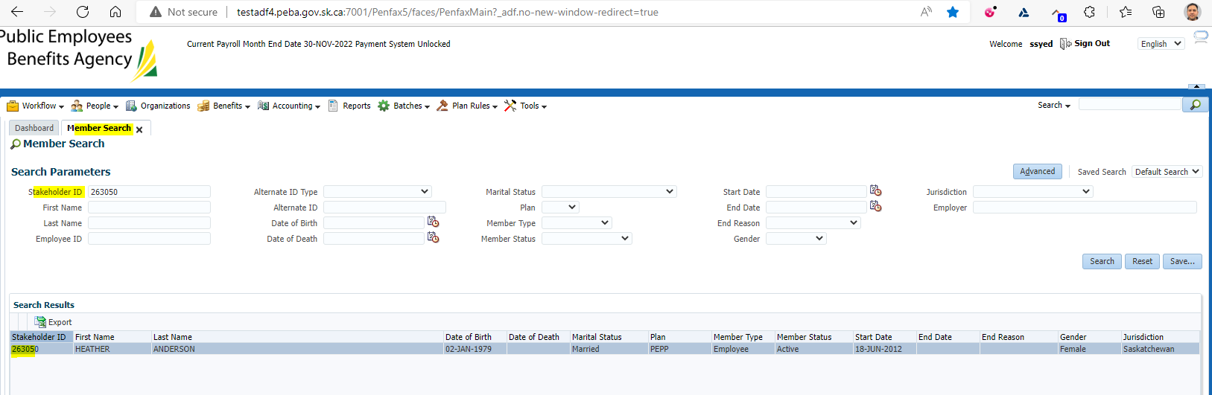

Click on DC SRB Claims  
Click Add

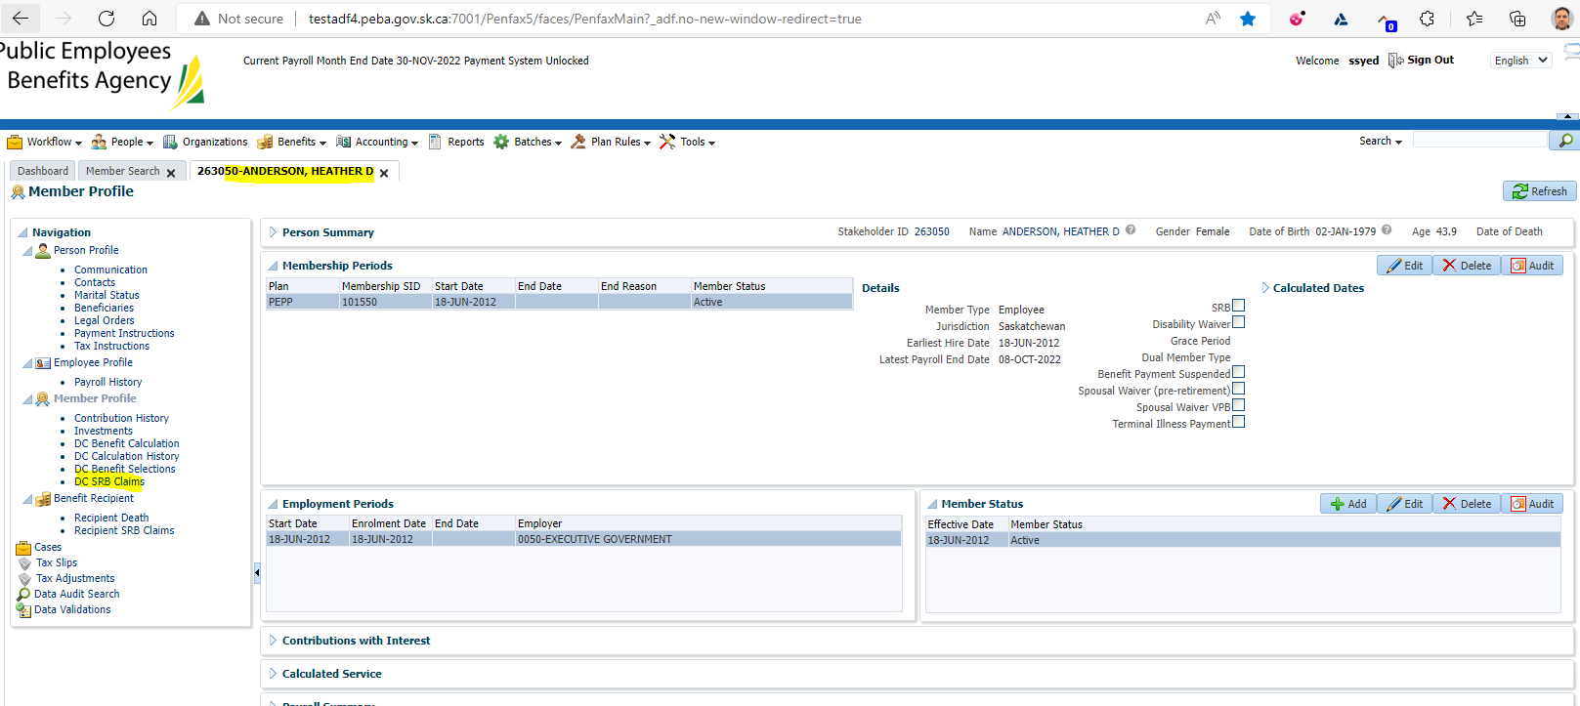

Under Spousal Relationship make sure to select the correct one  
Make sure estimate has a Checkmark in it  
Click Save

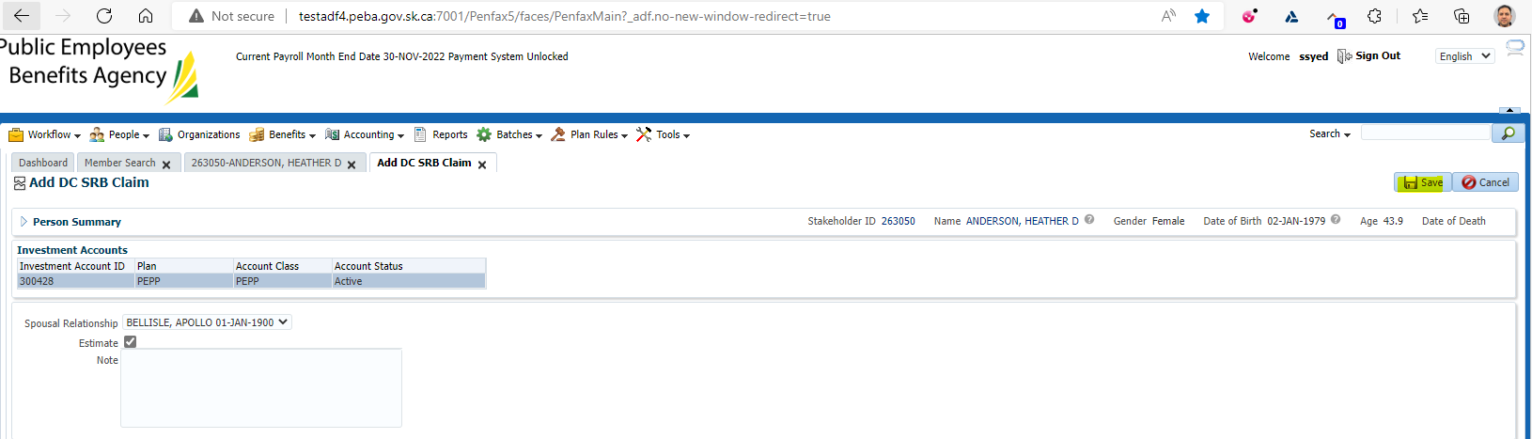

Under Method Select Share of Account with ROI  
Input Claim percent as 50%  
Change start date to be Jan 1, 2020  
Change end date to be current date  
Click Calculate

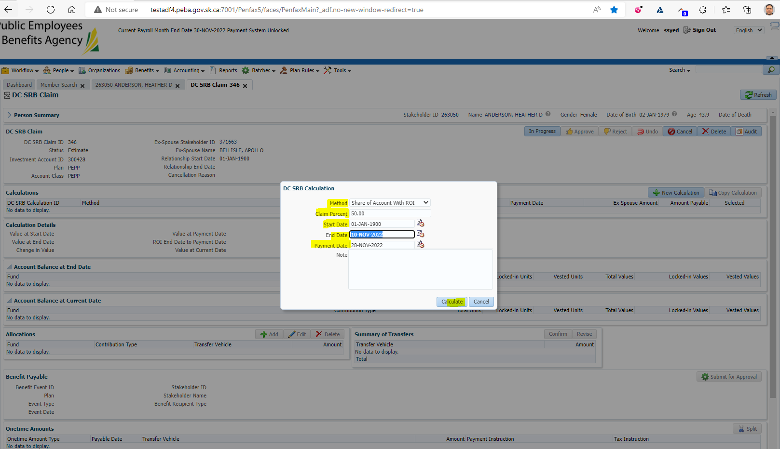

Under the Calculations you will see an Ex-spouse amount

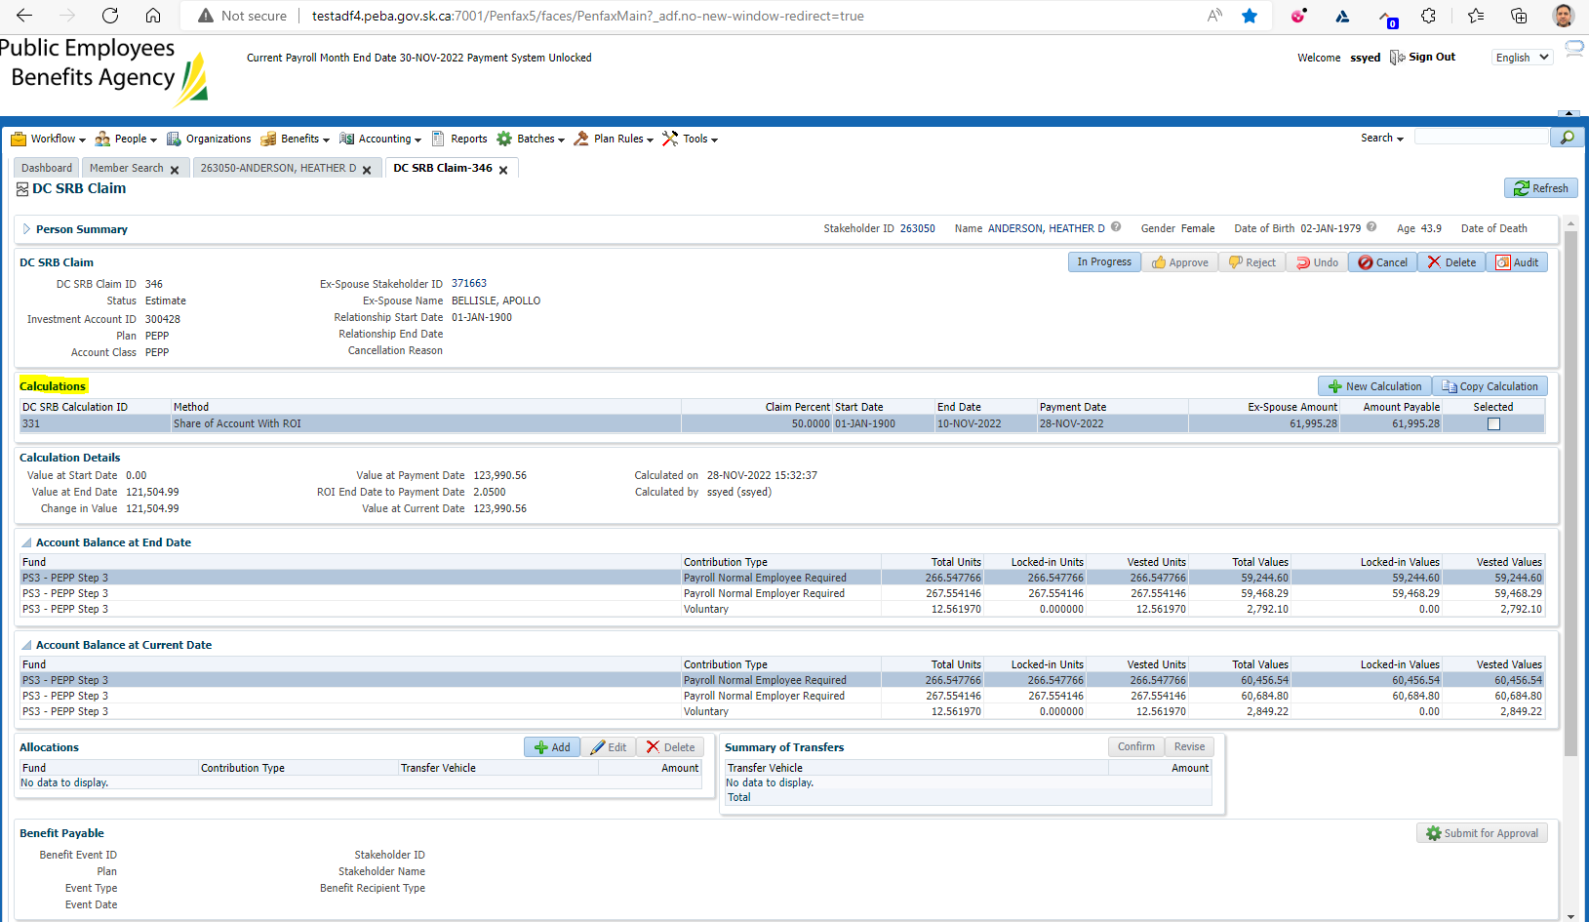

Under Allocations Click Add  
Under Transfer vehicle select RPP  
Under amount input the Ex-Spouse Amount  
Click Save  
Under Summary of Allocations click Confirm

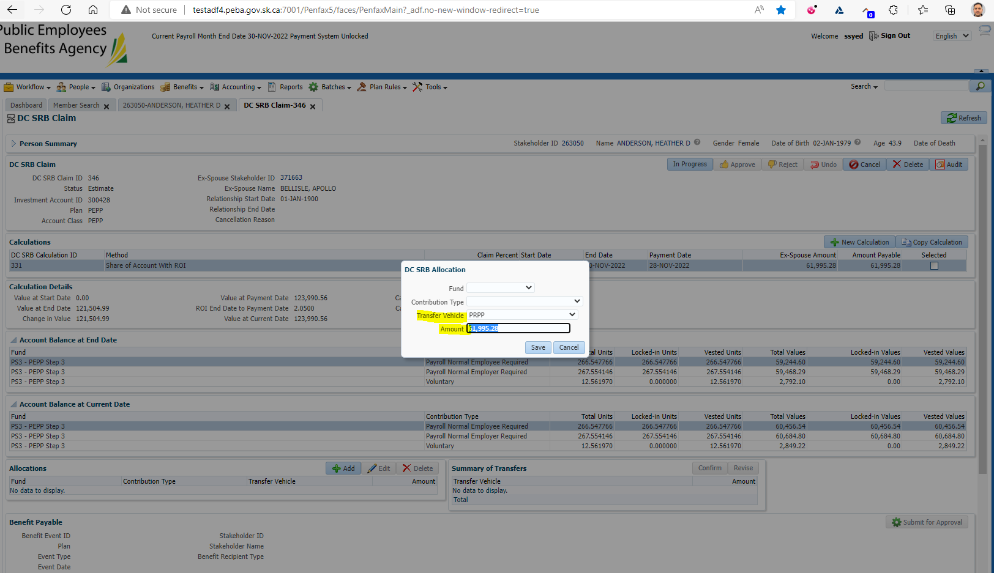

Under Onetime Amounts  
Add a payment instruction  
Add a tax instruction

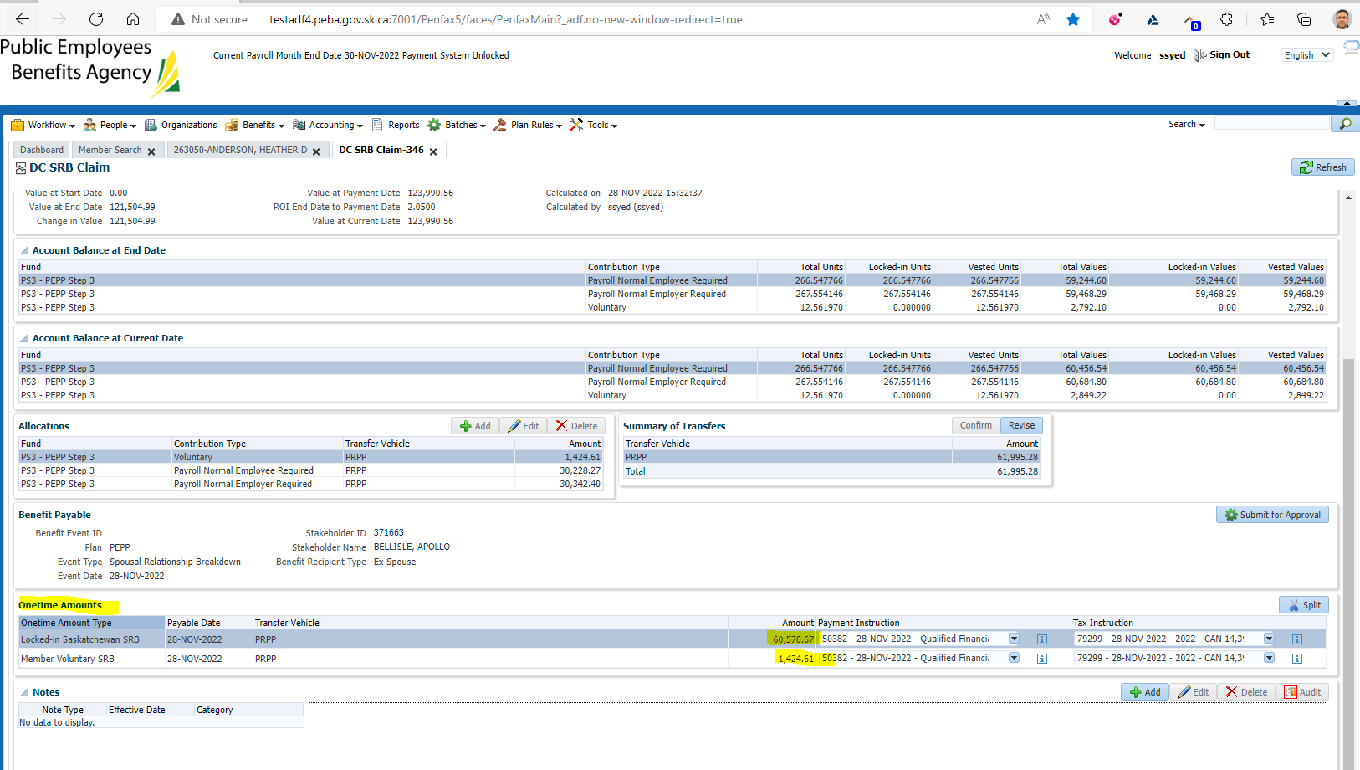

At the top of the screen under DC SRB Claim put In Progress  
Click Submit for Approval  
Approve the file

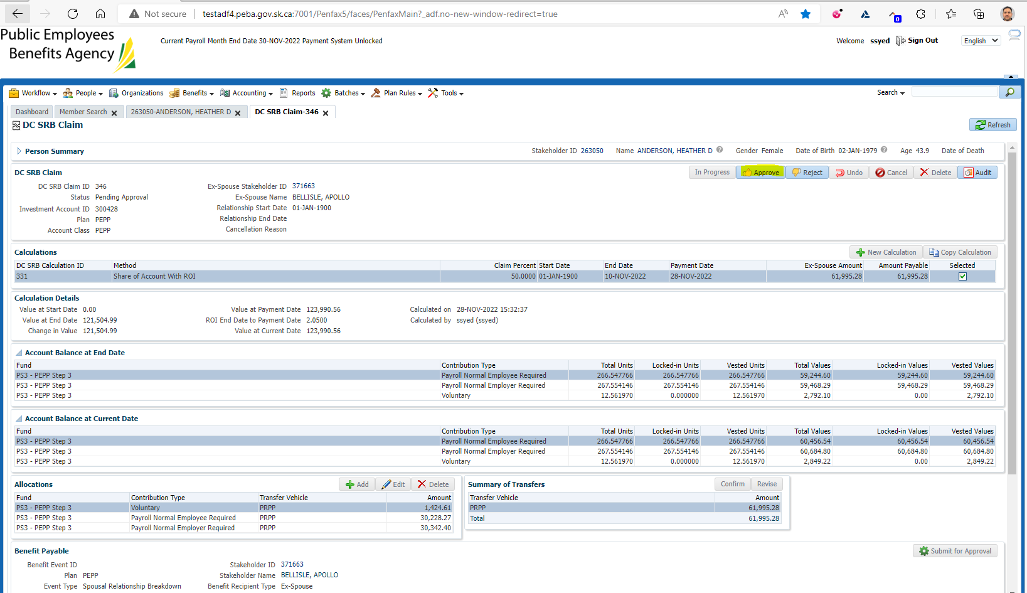

After Approval

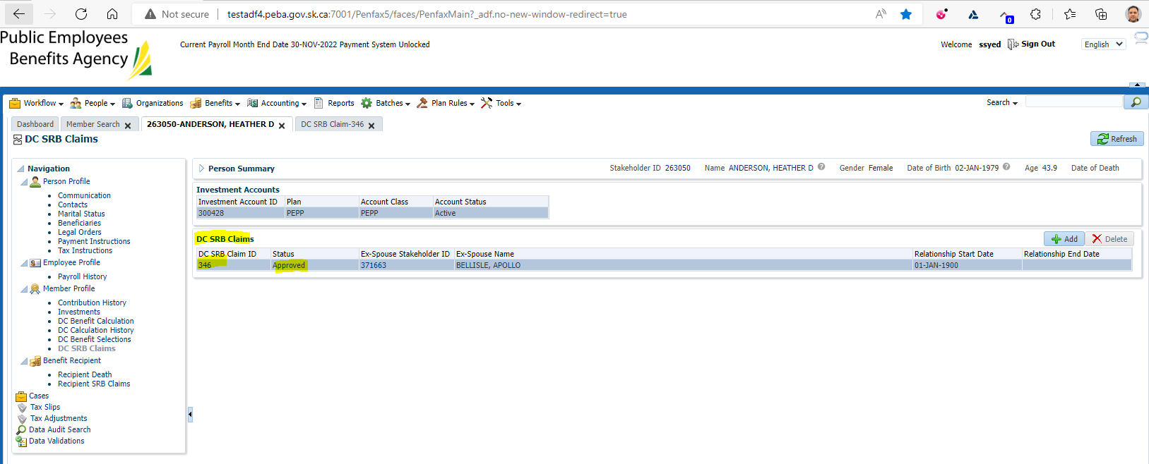

Wait for the overnight batches to run

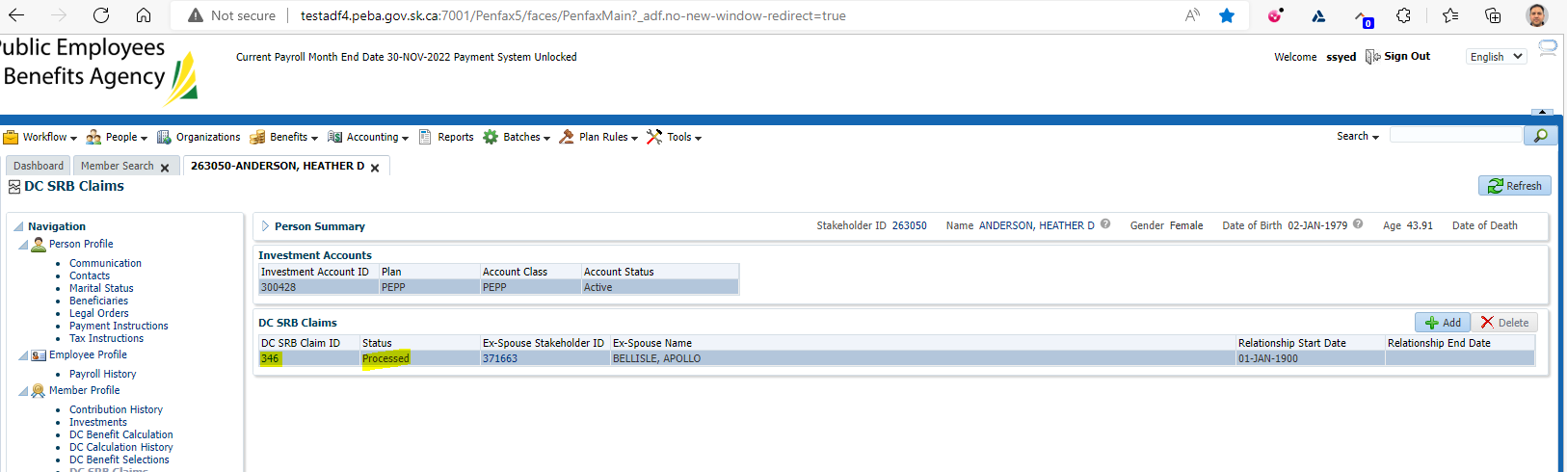

Verify the payment has been paid and that the cheque's were produced to the correct institution

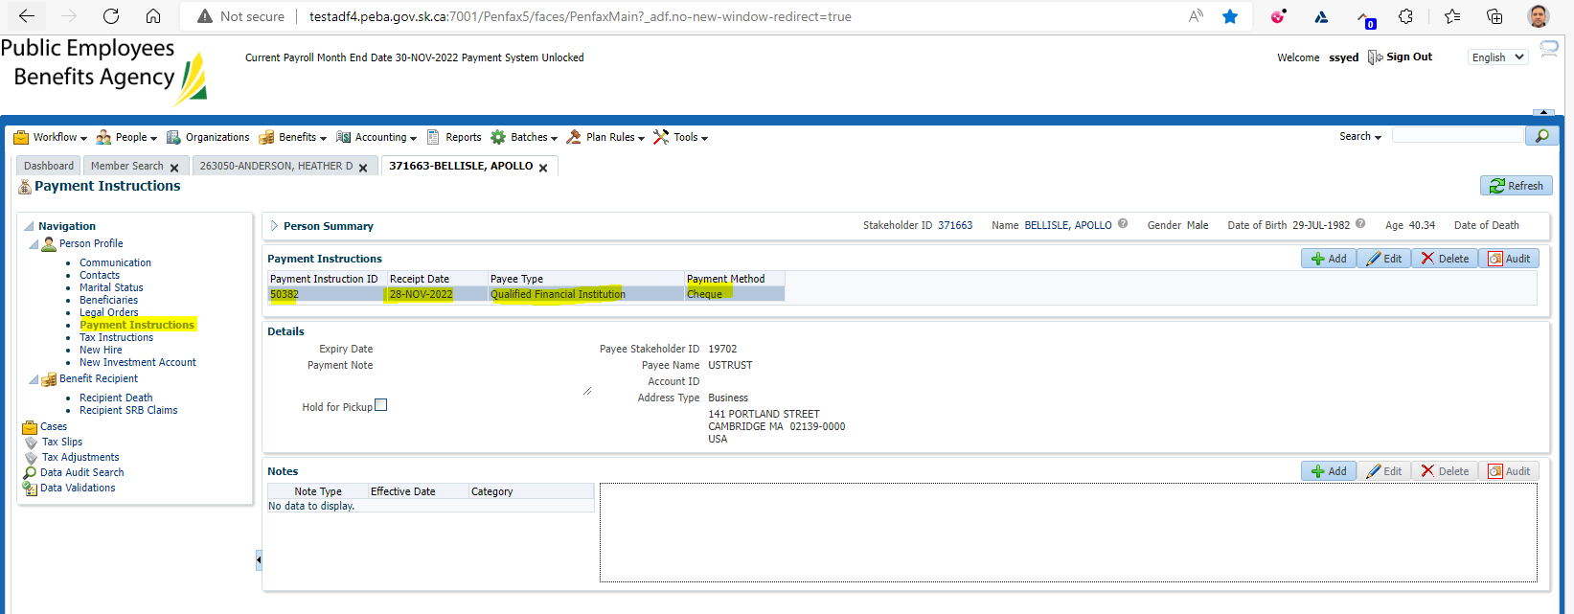

Verify that the Member Withdrawal Letter was produced for the member

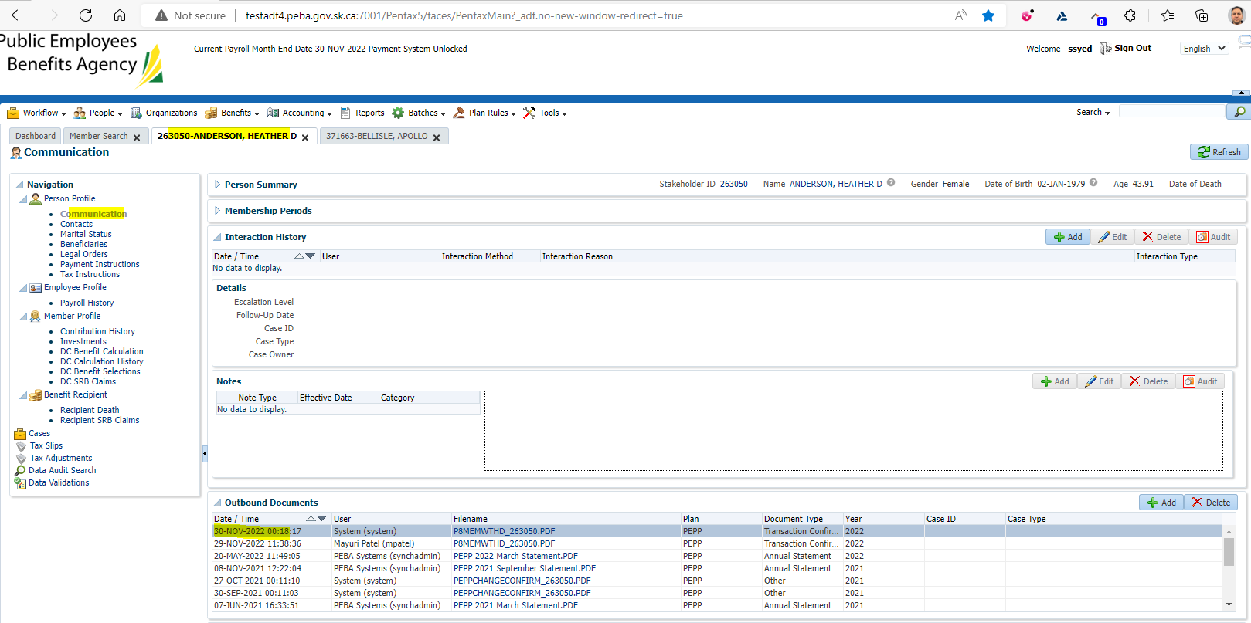

Verify that the Payment to Non-Member Letter was produced for the ex-spouse

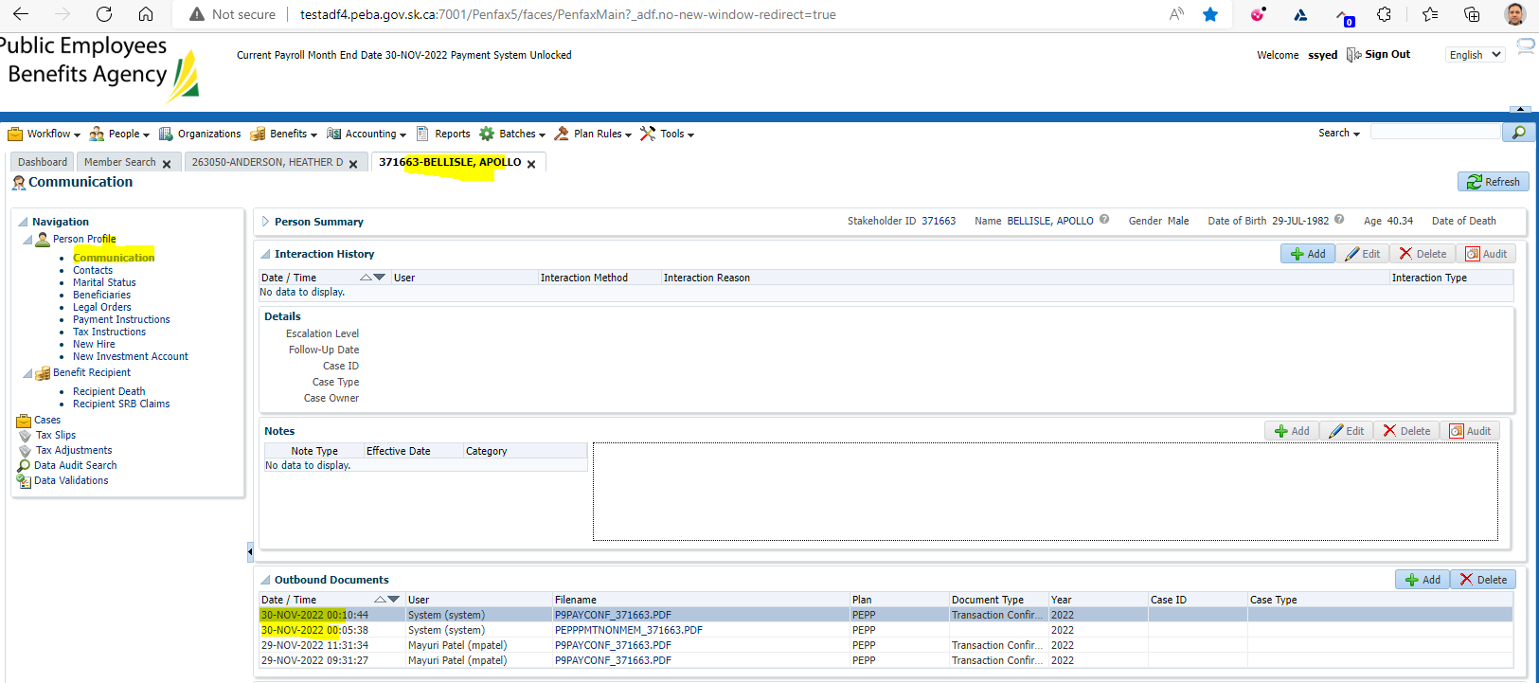

Verify that the Payment Confirmation Letter was produced for the financial institution

